

Electronic/Signal Project（APP）

Final Report

Group 1：

LIU Yang

Petal Ketul

GUO Xiaofan

KOVAYCIN Umut

JOHN ITOPA ISAH

# Summary

Modern aircraft prioritise passenger comfort and safety, and one crucial aspect of this is maintaining a healthy and pleasant cabin environment.

In response to this commitment, UKXY3000, an Aircraft Cabin Environmental Monitoring and Noise Reduction System. This specialised system is meticulously designed to monitor and regulate diverse parameters within the aircraft cabin and reduce the amount of external noise transmitted into the cabin, concurrently minimising the infiltration of external noise.

By doing so, the UKXY3000 ensures the provision of optimal conditions for both passengers and crew throughout the entirety of the flight.

# Project Context

In the rapidly evolving aviation industry, the emphasis on passenger comfort and safety has become a paramount concern. This project introduces an innovative solution – the Aircraft Cabin Environmental Monitoring and Noise Reduction System. To fully appreciate the significance of this project, we delve into various aspects of its context.

**1）Industry Overview:** The aviation sector is undergoing transformative changes to meet the escalating demands for enhanced passenger experiences and safety measures. Ensuring a comfortable and healthy cabin environment is integral to the overarching goals of modern aircraft design.

**2）Market Demand:** Current trends in the aviation market underscore an increasing demand for technologies that elevate the flying experience. Passengers and airlines alike seek solutions that address noise levels, improve air quality, and contribute to an overall positive in-flight atmosphere.

**3）Regulatory Standards:** Stringent regulations govern the aviation industry, particularly concerning cabin environment quality and noise levels. Compliance with these standards is imperative for ensuring the safety and well-being of passengers and crew. The proposed system aims to meet and exceed these regulatory requirements.

**4）Competitive Landscape:** As the demand for improved cabin environments rises, a competitive landscape has emerged. Existing and potential competitors are working on similar systems, each striving to establish a unique value proposition. Understanding this landscape is crucial for positioning our project effectively in the market.

# Objectives

## 3.1 Overall Objective

Based on several sensors, the passengers can receive the environmental information in the cabin via Bluetooth on their mobile phones, including values for temperature, carbon dioxide and sound.

When the value exceeds the safe value (preset value), an alert will be issued, and the crews and the passengers will be alerted.

For the crews, detailed numerical information will be received to adjust the air conditioner temperature, the air circulation system and the machines in the cabin to reduce the sounds. For the passengers, they will only be subject to simple reminders to adjust themselves.

## 3.2 Specific Objectives

For UKXY3000, the key features following:

1. **Carbon Dioxide Control**: Continuous monitoring CO2 content level.
2. **Temperature Control**: Precise control of cabin temperature to provide a comfortable environment for passengers.
3. **Real-time Alerts**: Instantaneous alerts for the flight crew in case of deviations from the set parameters.
4. **Active Noise Cancellation**: Implementation of cutting-edge active noise cancellation technology to reduce ambient noise within the cabin.
5. **Vibration Dampening**: Utilisation of materials and systems to minimise vibrations that contribute to noise.
6. **Engine Noise Suppression**: Targeted measures to reduce engine noise transmitted to the cabin.
7. **Enhanced Passenger Experience**: A quieter cabin enhances passenger comfort and reduces fatigue during long flights.

## 3.3 Hypotheses

The following hypotheses are made about the workflow of a complete collection-transmission-notification system:

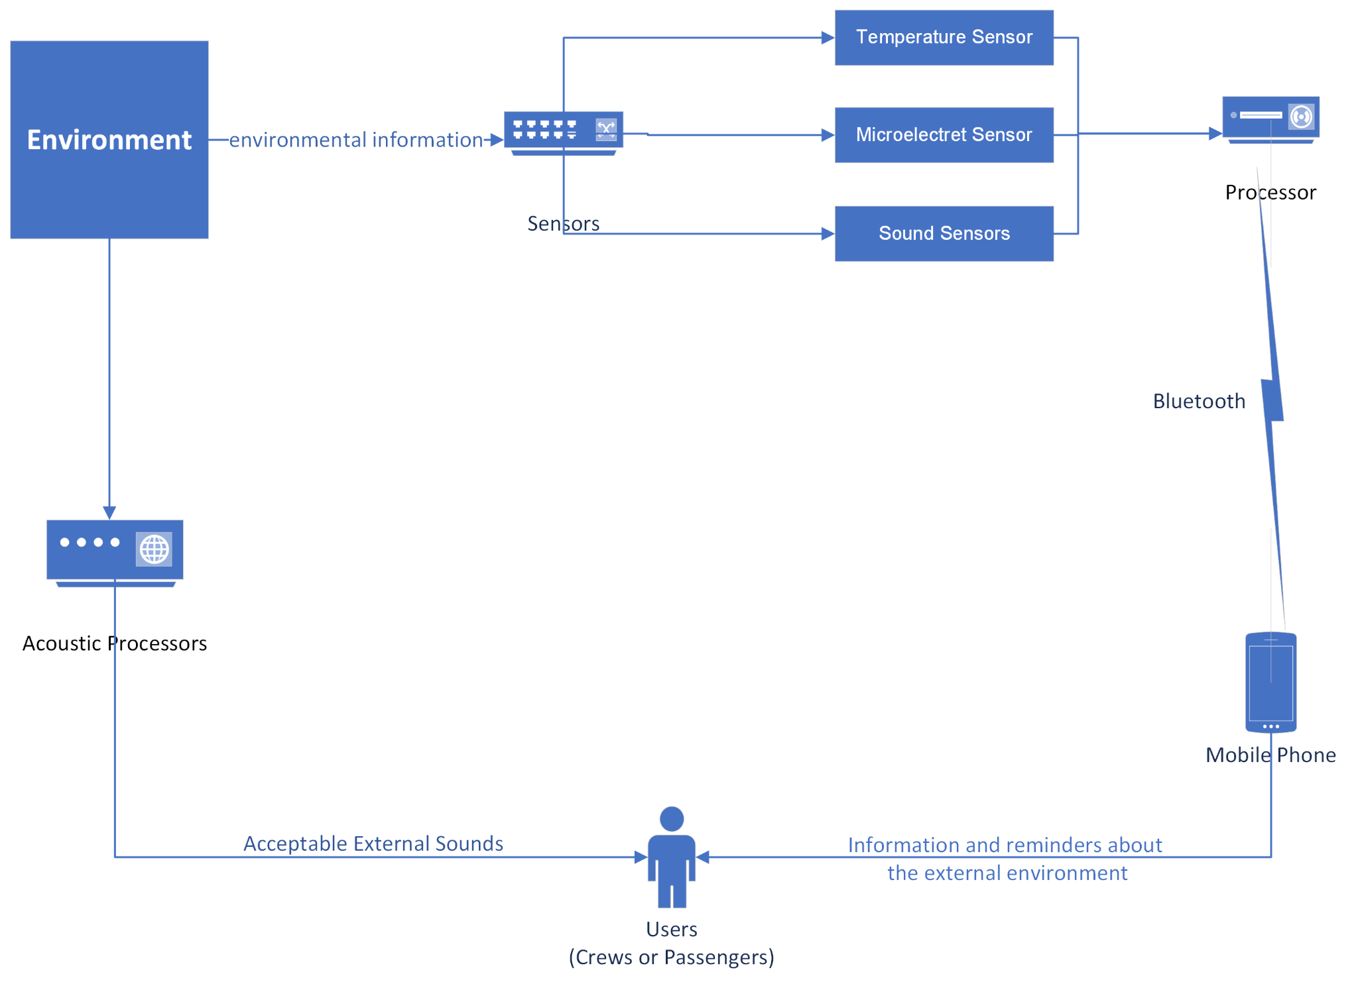

Figure System Workflow.

# Methodology

## 4.1 Research Design

This project is made of a closed loop system and displays aircraft compartment environmental indexes on the phone which include Temperature, Carbon Dioxide and Sound.

## 4.2 Data Collection

The compartment environmental data including temperature, CO2 ,sound will be collected via equipment deployed in the aircraft compartment.

## 4.3 Data Analysis

The collected data will be stored in the microcontroller. The temperature and CO2 will transmit to users via Bluetooth immediately.

The data of sound will be filtered. The sound of the compartment speaker and emergency alarm will be tagged green which means passengers should notice. Otherwise, the other source of sound like passenger’s communication, engines running or airflow impact will be defined if those sources of sound exceed the limit. If the sound level exceeds the defined value, the microcontroller will give instructions to passengers to wear hearing protector if possible and send feedback to flight crews at the meantime which they may need to either reduce the thrust to reduce the noisy level or check the compartment if there is any argument.

## 4.4 Tools and Instruments:

The tools mainly include sensors and electronic boards. But this is the least, required tools may be added later in the process and will be listed in this section.

Table Sensors

|  |
| --- |
| LM35 (Temperature) |
| MiCS-VZ-98-TE (CO2) |
| AMB-707-RC (Microphone-Omni) |

## 4.5 Ethical Considerations

This project is to detect the environmental quality of aircraft compartments and give instructions to passengers and feedback to flight crews. The collected data shall not be leaked and may be encrypted so as aircraft's flight status will not be disclosed for which may cause potential risks. And the data of sound will only be kept during each flight in the microcontroller then will be erased since voiceprint could be a personal account password in nearly years.

## 4.6 First Timeframe

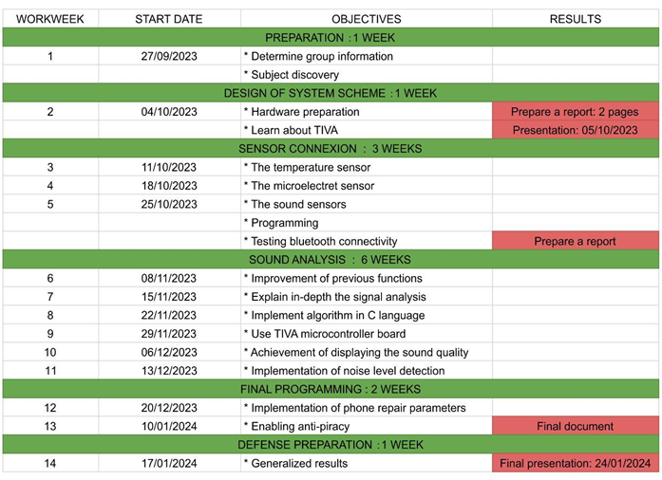

Figure Timeframe.

# Realization & Conclusion

## 5.1 Mission 1

### What the V cycle is?

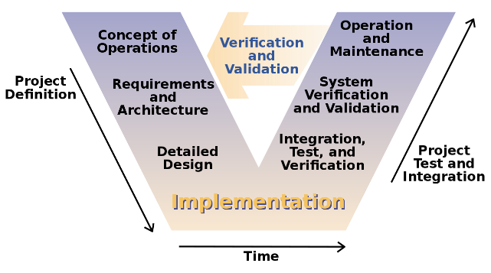

Figure V Cycle [1].

* **Concept of Operations**

Determine the overall concept and operational framework of the project (understand the goals, scope and customer needs and expectations).

* **Requirements and Architecture**

Determine specific requirements and define the architecture (functions, performance, interfaces, etc.).

* **Detailed Design**

Create more detailed design documents that describe how software components implement requirements and architecture.

* **Implementation**

The actual coding and building software phase. Write code based on design documents and ensure the code meets design requirements.

* **Integration, Test, and Verification**

Individually developed software modules are integrated together and integration tested to ensure that the whole works properly and meets requirements and design standards.

* **System Verification and Validation**

System-level testing to ensure that the entire software system meets user requirements.

* **Operation and Maintenance**

The software will undergo maintenance to fix any issues, as well as make updates and improvements.

* **Verification and Validation**

Throughout the entire V Cycle stages. After each development phase, corresponding verification and verification are carried out to ensure that the project results meet the requirements defined in the earlier phases.

### Connect a tricolour LED on ports of the microcontroller and generate the following colours: BLUE – RED – GREEN – YELLOW.

Figure Code to control the LED (in picture shows yellow).

* The function “**setup ()**” used to initialize settings, especially setting pin mode.
* “**pinMode(PIN_NUM, OUTPUT);**” set digital pin PIN_NUM to output mode.
* The function “**loop ()**” will be executed repeatedly.
* “**digitalWrite(PIN_NUM, HIGH);**” sets the level of pin PIN_NUM to high and the LED lights up;

“**digitalWrite(PIN_NUM, LOW);**” sets the level of pin PIN_NUM to low and the LED lights off.

* In this project,

|  |  |
| --- | --- |
| PIN_NUM | LED COLOR |
| 33 | RED |
| 34 | BLUE |
| 35 | GREEN |

1. Measure the current inside the LED when they are ON and explain it.

Figure Blue LED turns on.

* Blue LED (3.8 mA)

Generating blue light requires higher energy and therefore a higher forward voltage. However, due to the high efficiency of blue LEDs, the excitation current required may not be very high.

Figure Red LED turns on.

* Red LED (10.0 mA)

Since red light has lower energy, its forward voltage is correspondingly lower. However, to obtain sufficient brightness, a larger current may be required.

黑色的游戏机

Figure Blue LED turns on.

* Green LED (5.1 mA)

Green light has less energy than blue light, but usually more energy than red light. Therefore, the excitation current of green LED is between that of blue and red LED.

Figure Yellow LED turns on.

* Yellow LED (15.0mA)

Set the red and green LED lights to light up at the same time to mix yellow. The current is the sum of the current that lights up the red LED alone and the current that lights up the green LED alone (within error range).

1. What is the maximum current provided by a digital port of the microcontroller at level 1 and at level 0.

Table Maximum Ratings [2]

* From the table: IGPIOMAX ∈ [0 , 25] mA.

Imax when digital port of the microcontroller at level 1: 25mA.

Imax when digital port of the microcontroller at level 0: 0mA.

### Connect a potentiometer to an analog input of the microcontroller.

1. Read the analog value and display the result in volt every second to the console.

### Measure the power consumption of the board.

1. Precise the test condition (what is active on the board).

桌子上的电脑和键盘

Figure Current when Bluetooth & OLED Active

1. What will be the autonomy with a battery (choose a battery on the WEB)
2. What is the carbon equivalent of this power consumption?
   * Calculate Power:
   * Calculate Total Energy Consumption:
   * Convert to Kilowatt-hours:
   * Calculate Carbon Equivalent:

### Indicate the microcontroller parameters:

1. Size of the memories
   * Flash Memory: 256 KB
   * **SRAM**: 32 KB
   * **EEPROM**: 2 KB
2. Clock frequency

* 0 ~ 80 MHz

1. Explain the utility of a floating-point unit.

* A floating-point unit (FPU) is a part of the microcontroller that handles arithmetic operations on floating-point numbers more efficiently than software routines, allowing for better performance in processes that require floating-point calculations.

1. Describe some embedded peripherals.

The TIVA C series microcontrollers feature basic peripherals including:

* **Communication Interfaces**: UART, SPI, and I2C for data exchange with other devices.
* **Timers/Counters**: For measuring intervals and generating precise time delays.
* **Analog-to-Digital Converters (ADC)**: To convert analog signals into digital values.
* **Digital-to-Analog Converters (DAC)**: To convert digital values into analog signals.
* **PWM Controllers**: To generate signals with variable duty cycles, commonly used for motor speed control or LED brightness.
* **GPIO Pins**: General-purpose input/output pins for controlling and monitoring various electronic components.
* **USB Interface**: Provides USB communication capabilities, supporting device or host modes.
* **Floating Point Unit (FPU)**: Accelerates floating-point operations, enhancing mathematical computation performance.

### Use Serial1.xxx for Bluetooth on the board; pair with the computer first.

1. Display the values of question 2.a via the Bluetooth link.

Figure Current when Bluetooth Active

1. Download terminal emulator in the phone and display the value.

### Sold the OLED display.

1. Use the given library to display messages on it.

电子器材

Figure Display ISEP

1. Display a logo on the OLED display.

电子器材

Figure Display UKXY

## 5.2 Mission 2

### Connect the temperature sensor on an analog port and display the temperature.

Figure Temperature Display

1. What is the accuracy of the measurement?

Typical accuracy of the LM35 is approximately ±0.5°C at room temperature (factors such as power supply voltage stability, environmental noise, sensor placement, etc. may affect accuracy).

### Explain what Co2 measurements are from the provided sensor.

* 1. Connect the sensor to your system and display the measures.

### Connect the micro electret sensor.

* 1. Get a sound:
     1. Explain how this sensor works.

The Micro Electret AMB-707-RC is a condenser microphone that uses changes in capacitance to convert sound waves into electrical signals. The capacitor in the microphone consists of a fixed electrode and a vibrating membrane (electrode). When the sound wave hits the vibrating membrane, the distance between the capacitor’s changes, thereby changing the capacitance value and generating a corresponding voltage signal.

* + 1. How to make it work?
* Connect VCC to the positive power pin of the microphone.
* Connect the GND pin to ground.
* Connect the signal output pin to an audio amplifier or analog-to-digital converter (ADC).
  + 1. What’s the voltage generated by the sensor with your assembly?

The output of an Electret microphone is usually weak, usually between a few millivolts and tens of millivolts, depending on the loudness and frequency of the sound.

* 1. Amplified the sound to Increase reception sensitivity.
     1. What are the parameters of the amp to be used?
* **Gain**: Depends on the degree of amplification required, usually between 20 and 1000 times.
* **Noise Figure**: as low as possible to maintain sound quality.
* **Frequency response**: Covers at least the audible range of the human ear from 20Hz to 20kHz.
* **Input and output impedance**: match the microphone and next stage circuit.
  + 1. Design, calculate and simulate an amplifier.
    2. Simulate your assembly.
    3. Realize and test the assembly.
  1. c. Filter the sound (2nd order filter): The frequencies you process will be less than 2500 kHz.
     1. What are the possible filter schemes?
     2. Use the parameters of the filter (s) that will be useful to you to determine the value of your schema components (analytically).
     3. Simulate filter using the TINA or Tspice.
     4. Implement an analog filter and test it independently.

### Connect the sound sensors to your board.

1. Read the sensor with a sampling frequency of 10KHz and put the result in an array of 1000 cells.
2. Compute the power of your samples and check if it’s work by testing with different noise condition. Calibrate it with the decibel measure sensor.

## 5.3 Mission 3

# References

1. Figure V Cycle, <https://en.wikipedia.org/wiki/V-model>.
2. Table Maximum Ratings, Tiva™ C Series TM4C123GH6PM Microcontroller Data Sheet (Rev. E), Page 1358.